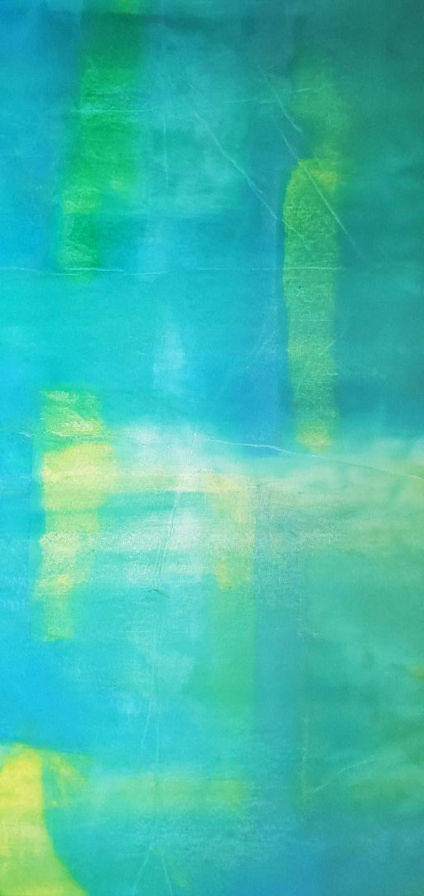

FORGIVE US, RAYSHARD BROOKS
acrylic and ink on canvas
65” x 30”

June 20, 2020

